**Pre requisites for Test setup –**

1. Get the project from below Git repository.
2. Ensure Java and Maven installed in the system and path added in environment variables as below.
   1. Add M2_HIME, MAVEN_HOME, JAVA_HOME in system variables.
   2. Also add %MAVEN_HOME%\bin and %M2_HOME%\bin in Path variable.

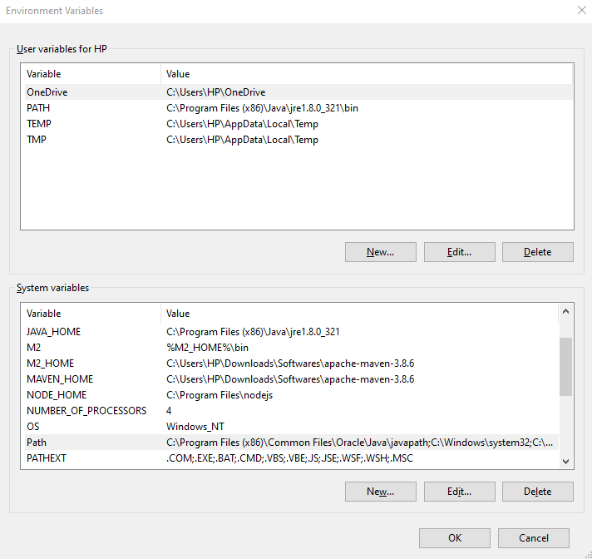

**Steps for Test suite execution -**

1. Open command line
2. Navigate to Project folder

* Suppose your project path in local directory is ‘C:\Users\eclipse-workspace\TrivialPublicAPI’. In command line navigate to above folder by giving command **cd C:\Users\eclipse-workspace\TrivialPublicAPI**

1. Execute the cucumber test runner file by giving below MAVEN test execution command.

**maven test**

1. Once execution completes, check the reports in below project folder path. –

**TrivialPublicAPI\target\cucumber-reports**

Reports available in xml, json and html format. We can directly open html report in any browser to check execution details.